Seascape Golf Course

1st Round Club Championship Results. 06/25/2022

***Low gross contenders:***

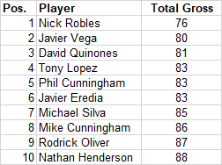

***Low net contenders:***

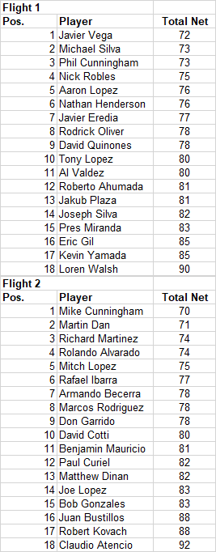

1st place team - Javier Vega/Michael Silva

2nd place team -  David Cotti/ Mike Cunningham

CTP- #6 Aaron Lopez  #14 - Rich Martinez - #16 Rodrick Oliver

Money Holes $$ - #8 Al Valdez 8'11''      # 12 Javier Eredia 3'11